FYP Progress Report
P2P IPTV – TD1a-09

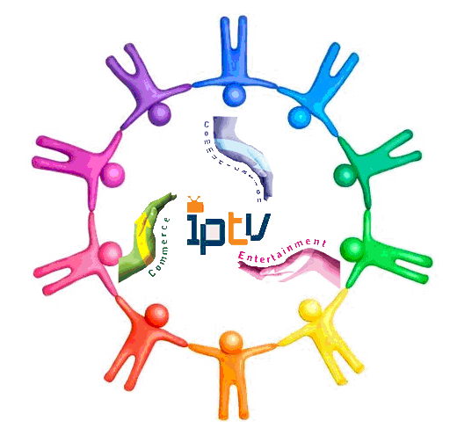

Project Supervisor : Prof. Danny Tsang
Signature : ___________________

Conducted by : Cheng Wen Chi, Vinci (07481136)
Chiu Kwok Shing (07323530)
Choi Kwok Yam, Alex (07483512)
Table of Contents
1 Overview 3
1.1 Introduction 3
1.2 Aim and Objectives 3
1.3 System Block Diagrams 3
1.4 Design specifications 4
1.5 Report Outline 4
2 Background 5
3 Reference 7

1 Overview
  - Introduction
With the development of networking technology, broadband is become the more and more popular in the world. According to data and statistics from Office of the Telecommunications Authority (OFTA) [10], the household broadband penetration rate of Hong Kong is reaching almost 77% as at May 2008, which is higher than the average standard of developed countries [11]. Having such superior environment, lots of people have a great thirst on high quality networking multimedia service.
In accordance with the statistic of OFTA in 2009[12], there’re 1.08 million IPTV subscribers in Hong Kong at December 2008 which is the highest in the world in terms of household penetration.

Home users demand for higher quality of online video service. Such as YouTube, the most famous video sharing website has just announced that users now have the option of watching some video in 720p HD, much better than 320x240 fps video in the past.

To provide such high quality online video service, traditional client-server mode IPTV has its limit. Large amount of upfront investment is required to build up high efficient server and network which make investor hesitate to start of.

Peer-to-Peer (P2P) has a great advantage over the traditional client-server model. In P2P model, clients will work as a part of service provider when they join into the mesh network, which lower the workload of server. Applying P2P technology, the required network resource from the server will be reduced. Thus, we can provide more users with same amount of resource. Combining the well developed broadband network in Hong Kong, we can use P2P technology to provide user high quality IPTV.

  - Aim and Objectives
This project examines streaming Internet Protocol Television (IPTV) over peer-to-peer networks. The aim of this project is to investigate the different approaches of P2P video streaming to build up a low delay, high quality IPTV application, and different P2P algorithm may be tested, such as pull-based, pure push, hybrid, etc.

  - System Block Diagrams
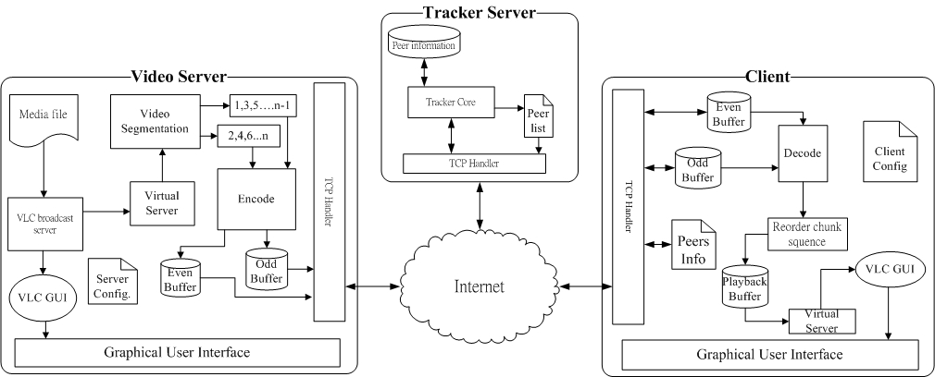
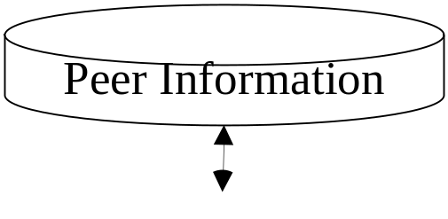

1.4 Design Specification
The product will be composed by 3 parts: Main Server, Tracker Server and Client side application.

For the Tracker server, it’s the key link of the whole system. It will track and save all peer information that join into the system, include the server and client. All peers will first join into it and register in the peer list, the Tracker server will then return a list of peer information to it.

The main server will be contained all the source of video which is the fundamental of the whole system. It will create buffer and encode it to stream out.

Client side application provide a GUI interface to end user to watch the video provide by the system, it will build up a virtual server to stream out decoded video data to the VLC core player.

1.5 Report Outline
From the above information, you will have a simple concept what we are going to achieve in this project. We will explain it more detail in the following sections.

You may obtain the background information of what P2P IPTV is in the next section. We will explain the methodology that we will apply in section 3. At the end of this report, will present what we have achieved in the current state.
- Background
P2P model is widely used on file or data sharing in modern internet. In P2P model, clients become one of the participators in data upload. Transmission speed is no longer based on server throughput (server-client model), but shifted to the throughput of both peers and server. Theologically, the performance of P2P network will be even improved with the increased number of peers. As bandwidth of client computers are increased rapidly in the past years, it optimized the working environment for P2P model. Workload and dependence of server throughput is also reduced by P2P model. As a result, a much stable and high data throughput can be achieved in the same topology.

Entertainment has become the main function of home PC. Online Movie, TV, music are common home entertainments. Users enjoy different kinds of online entertainments through their broadband connection in different countries. Most of the online multimedia applications need to deliver a large amount of time sensitive data. The multimedia streaming leads to a significant problem for server to deliver a stable service to large number of clients. P2P model is then become one of the most feasible solutions for multimedia data delivery. IPTV is a signification example of multimedia streaming that benefit from the P2P model. In the past, it is infeasible to deliver real time TV broadcast through internet. The throughput of server does not meet needs of high bit rate of client in client-server model. However, after P2P model is applied, the throughput of download stream in each clients have significant increase, and data streaming is then allowed to support the high bit rate of video. As a result, most of the popular P2P IPTV systems are using P2P model to provide their service.

High and stable throughput of data streaming is critical factor of P2P IPTV performance. The construction of P2P streaming network will drive the performance of data streaming. This means construction of P2P streaming network is most important for P2P IPTV.

There are 2 major design issues for constructing a P2P streaming network:
- how to form an overlay topology between peers
- how to deliver video content efficiently
According to the researches [3] [4], there are 2 common basic approaches to construct P2P network, mesh pull and tree push. For tree push, peers are connected in tree-shaped overlay and video data is pushed out from root (server) to peers by passing through the tree hierarchy. For mesh pull, peers form a mesh-shaped overlay and they pull video from each other by send request to peer.
Recently, there are numbers commercial P2P IPTV has been successfully deployed. According to articles [1][2], those IPTV users are increased exponentially in these few years. PPStream, PPlive, SopCast are the examples of the common P2P IPTV. Most of them applied the mesh pull algorithm to deliver the service, moreover applying TCP to ensure the reliability of delivery. The mesh-pull system is popular for P2P IPTV as it is relatively simpler design principle than tree push. However, they reached some common problems, such as large initial delay, high reconnection latency and high disconnection rate.

In this project, our aim is to implement a high quality and stable IPTV system with a optimize P2P model. After studying the academic research [4], it indicates tree-push provide a better performance in practice. Tree push cause a lesser overhead in data streaming over mesh pull and it will be further discuss on methodology part. Our project will deploy with base which used tree push system and provide further enhance with several algorithms. These algorithms include multiple trees model, data sub streaming, and MDC (multiple description coding). The approach to implement these algorithms will also be clarified in the methodology section of the report.

- METHODOLOGY
3.1 Knowledge Need to Execute the Project
Basic networking knowledge; C/C++/C# programming skills; Media format encoding/decoding concept; Algorithm knowledge (e.g. binary search); Mathematics (e.g. linear algebra).

3.2 Project Plan
3.2.1 Design Phase
Description of the Proposed Solution
Mesh-pull architecture: Bearing strong similarities to BitTorrent, mesh-pull streaming deviates significantly from BitTorrent in various aspects [3]. The mesh-pull systems apply a simple design principle and suitable for high dynamic, high-churn P2P environment [5].In Mesh-pull streaming, the host exchange Buffer Map [7] and retrieve missing chunks. Every chunk has a playback deadline, so video chunk scheduling algorithm is indispensable. Gossip based peer search algorithm is implementing in mesh-pull system to support large-scale group communication. However, gossip algorithm incur various implication, i.e. delay may occur in searching peer; tracker server may only handle part of peers in the system and lose the global view of the network[3].Another, mesh-pull systems always suffer from high traffic overhead, long start-up delays, video channel switching delays and peer playback time lags[3].

Tree-push architecture: Tree-push systems may achieve high throughput, low overhead, fast start-up time and small delay, if the tree structure does not break down due to peer churn and peers at the higher level of the tree have sufficient upload capacities to support streaming for their children peers [6] Another, tree construction mechanism can optimize the tree so as to reduce stress on the underlying network. In tree-push streaming, peers share the video chunk to their children peers immediately. Buffer Map [7] and retrieve missing chunks will not apply in this streaming system.

However, tree-push system is instability. When one node is losing, it affects all other nodes below its hierarchy.

In this project, tree-push will be used to develop the overlay topology. Tree-push provides smaller delay time of video playback compare with mesh-pull. This advantage is appropriate for IPTV but tree-push is instability. Therefore, we enhance with several algorithms to minimize the instability. Multiple trees and sub streaming will apply to the tree-push. Sub streaming divide video stream into different sub-stream with equal sizes, and each sub-stream is assigned a sequence number to represent its play black order in the stream [8]. Each sub-stream use separate tree to broadcast. Peers join as many trees as three are sub-streams they want to receive. Another, we will implement Multiple Descriptions Coding (MDC) to improve the video play back quality. MDC constructs multiple independent multicast trees, one for each sub-stream. A peer can improve its media quality by joining more multicast trees under the constraint of its download link capacity. More importantly, the departure of one ancestor in a multicast tree does not severely degrade the media quality of a peer, since it can still receive the majority of sub-streams from other multicast trees [9].

Technical Challenges and Merits of the Project
In the project, we encounter numbers of technical challenges during development:
1. The lagging problem of video playback
Solution: Buffer is added in the receiving network thread. Buffer accumulates a small number of data chunks before playback in local VLC player start. When the data chunk in buffer is below certain amount, the playback will be PAUSE until the received data accumulate to certain level again. By this approach, the cases of continuous lag are reduced when the download bandwidth is unstable.
2. Different clients have different playback performance on same video source which due to variation of their bandwidth
Solution: provide a system to test the bandwidth of each client. Build a suitable size local buffer for network sub stream and video playback as to ensure the quality of delivery video
3. The system use a lot of CPU processing power even the video stream is stopping. The problem is mainly cause by the thread of network stream
Solution: add the thread sleep inside the endless loop of network stream thread
4. Dead of video playback after applied the video sub stream in multiple trees topology. The problem is caused by incorrect reconstructing of playback video stream.
5. After applied the sub stream delivery of video data chunk, delivery of data chunk are disordered. It leads to problem on reconstructing the original video stream for playback in peers.
Solution: A sequence number is given to each data chunk. When Peer receive data chunk from different sub stream in each thread, data stream will put into buffer of each thread. A distinct thread which responsible for merging sub stream will reordering the data chunk and put them to the playback buffer according to data chunk sequence number.
There are 2 main Metris in this project. This project provides the practical implementation details of tree push model P2P. It gives a well demonstration on applying tree push model for P2P IPTV system. This will helps to promote the tree push model for commercial P2P IPTV system. Besides, MDC is another valuable part of this project. In this few years, MDC (multiple description coding) is started to apply on video streaming over internet. Different video encoding standards are also using MDC Video as algorithm bases. However, researches focus on applying MDC to P2P video streaming model is limited. Our FYP will provide a feasibility review by the experimental implementation of MDC and P2P video streaming.

Deliverables
The final goal of our project is to deliver an efficient and stable P2P IPTV system. The final product should be implementing on tree push bases which include several of enhancements on video streaming, for example sub stream, MDC, etc. The demonstration of product will provide a completed P2P IPTV system which include video server, tracker server and support large number of client peers. It will able to deliver a smooth and small delay live video streaming to every peer in the system. Moreover, it provides a stable services under unfavorable condition such as unstable bandwidth and continuous disjoin and rejoin of peers in the P2P TV system.

3.2.2 Implementation Phase
The ultimate target of our project is to build up an application that can provide QOS IPTV under P2P model.
We can divide our work in the past few months into 5 states.
States | Details
State 1 | One-to-One Client-Server Model Video Streaming Implementation and Testing.
State 2 | One-to-Many Client-Server Model Video Streaming Implementation and Testing
State 3 | Cool Streaming Implementation and Testing
State 4 | Implementation of Multiple level tree structured P2P Network with Tracker Server
State 5 | Further enhancement on sub stream. E.g. MDC, hybrid mode streaming
3.2.3 Testing Phase
To test the functionality and correctness of our system, we have applied different tests within different States, find out the weakness and improve them.

Implementation Test-1
Title: Connectivity Test
Purpose: Confirm the protocols and the system working properly both in wired and wireless network.
Methods: 1. Load the application into different computer, one of them act as Server, others are clients.
2. Set up the system, connect them through wired and wireless network respectively, and mark down any abnormal behavior of the application.

Implementation Test-2
Title: CPU Resources Consumption Test
Purpose: Find out the CPU resource that consumed by the application
Methods: 1. Set up the system, and start the Windows Task Manager, mark down the initial CPU usage that shown in Performance tag.
2. Start the system, mark down the CPU usage during Video Streaming under different condition.

Implementation Test-3
Title: Quality of Service (QOS) Test
Purpose: Test the video quality and application’s performance
Methods: 1. Set up the system, prepare video files with different bitrates
2. Stream out the videos in the system, check and mark the video quality and system stability with different condition, see if there’re any packet losses or delay is out of our acceptance range.

3.2.4 Evaluation Phase

Since the system is still under construction. Purposes of most implementation tests are designed to improve the system.

For the “Test-1”, we have tested connection behavior of our applications under different condition – connect through wired / wireless network, LAN / Internet. Mark down the conditions that will cause disconnection and then update the program to solve the problem.

For the “Test-2”, check the amount of CPU resources that will draw by our applications during running. Review the source code, optimized the codes to reduced the CPU resources consumption.

For the “Test-3”, check the QOS of the system, and track the operation of the applications, examine the condition that can provide the best QOS by the system. Update the source code to improve the QOS of the system.

  - Schedule of Responsibilities

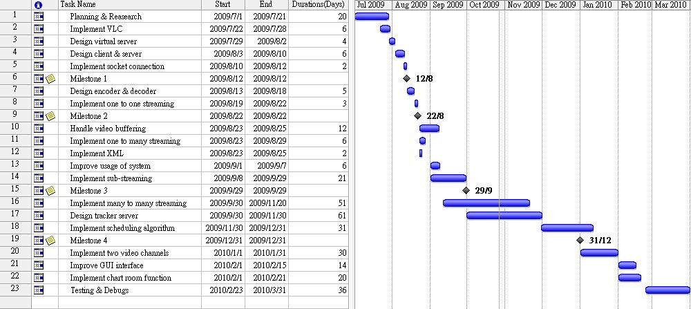

Milestones 1: Client connects to server and requests the data packet

Milestones 2: Client can playback the streaming video through one to one broadcasting.

Milestones 3: One to many broadcasting and using sub-streaming method.

Milestones 4: Showing basic P2P IPTV system.

Responsibility of each Task:
Name | Task Number
Cheng Wen Chi | 1,4,8,10,11,13,17,18,20,22,23
Chiu Kwok Shing | 1,2,12,16,18,20,21,23
Choi Kwok Yam | 1,3,4,5,7,8,11,13,14,18,20,23

ACCOMPLISHMENTS (Cheng Wen Chi)
I worked in different parts in project. In each part, I worked by studying algorithm, coding and testing. There are 2 main sessions which I focused on. The first is the establishment and maintenance of overall topology in P2PTV system. The second session is the construction and reconstruction of data chunk with buffering system.

In the first session, my goal is to implement an effective algorithm to build the topology which provides a reliable connection between peers. These connections will support the exchange of large amount time sensitive data packet. After discussed with my groupmates and Professor, we decided to use the tree push models as the bases of P2P TV. Thus, I started to study the tree algorithm and find the effect algorithm to build the topology.
In the tree models, studies indicate that there are mainly 2 ways to increase efficiency.
- Keep an almost balanced tree without reconnection
- Keep peers with larger bandwidth in near to roots
In computer science, there are different algorithms to maintain a balanced tree. E.g. AVL tree. Those algorithms require the changes of relationship between nodes when balancing the tree. This means disconnection and reconnection of peers is a must to applying those algorithms in tree push system. However, disconnection and reconnection cause a large overhead when I am tested it over the internet. The control message exchanges between peers for initial new connection cause a large overhead.

Thus, I rejected the idea of reestablish connection and started to focus on peer initial join problem and reconnection problem. As to reduce the depth of tree, peer should join peer that near the root when they join the system. As a result, the depth of each node in the tree becomes the most important information to determine the joining peers. As to simply the determination of nodes depth, I proposed to build a tracker server which provides similar function as tracker in P2P file sharing system. The tracker server in the P2PTV system will become a centralized database for Peer information. This information will include IP address, nodes depth, and bandwidth.
Tracker will maintain all Peer information of both video server and peers and provided to peer for connection establishment.
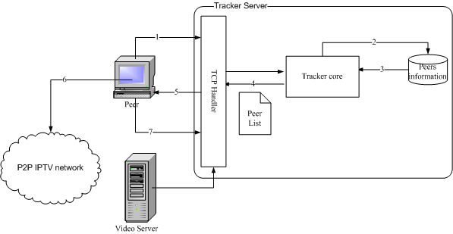
Figure 1.2 Implementation of tracker
In figure 1.2, it shows the implementation idea of the tracker system. In the P2PTV system, Tracker server will be the first session to start up. Tracker will then started to listen require message from video server and normal peers in system. When a new channel is started by a video server, the video server will register its channel information to Tracker Server.

When a new peer joins the P2PTV system, it will send a request message to the tracker server. The tracker core will then get request information from TCP handler and it will compute an appropriate peer list. The Peer list is lists that contain details of peers which provide service to others peer. When the Peer received the Peer list, it will attempt to establish a new connection with those peer based on its local policy. The process of peer selection is computed in client because I want to reduce the workload of tracker server. After it connected to peers, it will give the feedback message to the tracker and the tracker will updated its peer list.

In the current Phase, tracker server is implemented and it allow to keep all the peers information. However, there is problem on updating the disconnected peers. The current algorithm causes a very TCP overhead on detecting the disconnected peers in P2P system. It greatly increases the load of tracker server. The peer update algorithm should be redesign to increase the availability of the tracker server.
The next part that I response for is the buffering algorithm in the P2PTV system.
The goal of the buffer is to support the sub streaming algorithm and enhance the playback quality of the streaming video.
As sub stream is received from different peer by different threads in the program, the buffer should provide a platform for the playback thread and the network streaming thread to exchange data chunk.

The figure below show the structure of the buffer system:
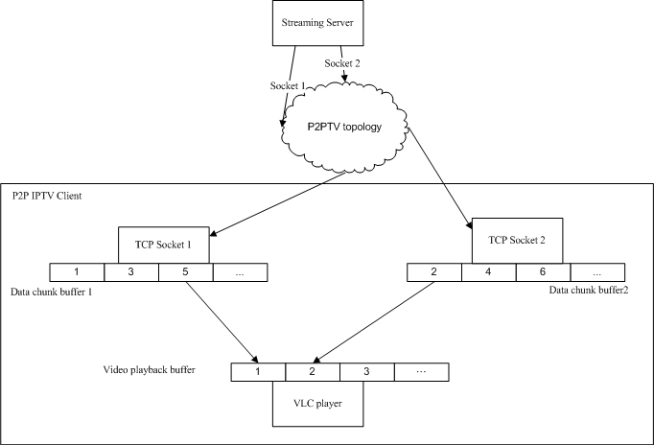
The designed of buffer system is actually based on the cool streaming algorithm. When network thread receive data chunk from peer, it will store the data chunk in is chunk buffer. At the same time, the video reconstruction thread will read the chunks in each data buffer and reconstruct the original video stream based on their sequence number. The reconstructed buffer will then move to video playback buffer and it will then played by VLC player thread.
The multithreading process causes a great difficulty on implementation. As the merging thread, network thread and playback thread are operated parallel in system, the buffer may read and write by different threads at the same time. This needs a well defined algorithm synchronize the thread. The miss handling of thread may causes playback over flow problem or lagging problem in video playback.

ACCOMPLISHMENTS (Choi Kwok Yam)

Virtual Server:
The virtual server is use to handle VLC broadcast data. It read the broadcast data from local buffer and then sends the data back to core player through local loopback address. It is meaning that the core player will connect to the address (http://127.0.0.1:port number) to playback the video. We can see the operation flow in Fig 4.1. Using this method, we do not create a new core player which read the data directly from the buffer. As a result, we can see that this method is work between VLC media broadcast server and VLC media player.
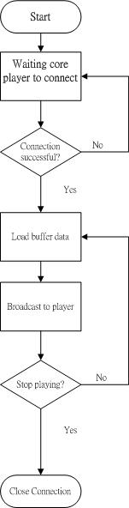
Fig 4.1 Flow chart of virtual server operation

Encoding/ Decoding:
Sub-Streaming method is implementing to our system. In main server, the streaming chunk will be encoding before sending it out. Client need to decode the packet and reorder the streaming chunk to playback the video. In fig 4.2, each packet divides into two parts: Header (Sequence Number + Bytes) + Data (Streaming chunk). Sequence number is use to reorder the streaming chunk. Byte is the size of streaming chunk in data part. Maximum size of each streaming chunk is 3000 bytes.

<Header> <Data>
182 bytes 3000 bytes

Sequence Number Byte Streaming Chunk

Fig 4.2 Structure of packet

Reorder sub-streaming algorithm:

Figure 4.3 shows a flow chart of reorder algorithm. In this algorithm, we need to handle sub-streaming buffer and playback buffer. Two buffers are running in separate thread. It will cause pointer overflow easily when we compare two buffer indexes. Therefore, we design this algorithm base on sequence number instead of buffer index.
Current sequence number is the sequence number of last input chunk in sub-streaming buffer. Target sequence number is the request number of playback buffer. If the current sequence number is equal zero, the function will go to stop. We find the target chunk in sub-streaming buffer when current sequence number larger than or equal to target sequence number. In this comparison, we prevent pointer overflow occur. Although playback buffer requests data speed faster than the input data speed of sub-streaming buffer, sub-streaming buffer will not cause pointer overflow by playback buffer. If the request chunk does not exist in the buffer, the algorithm discards this chunk and updates the target sequence number for next request chunk.
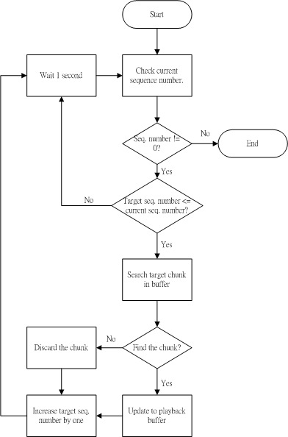
Fig 4.3 Flow chart of reorder sub-streaming algorithm

ACCOMPLISHMENTS (Chiu Kwok Shing)
Besides system & algorithm design, testing and debugging. In the past few months I mainly take part in 3 sections within the project: VLC player plug-in implement investigation and development, system Library Development and Client-side application Development.

VLC player plug-in Development

A
B

f

Just at the beginning of our project, we have tried to develop the whole system by our own. We have developed the GUI interface with Windows Media Player Plug-in. Develop the encoding/decoding algorithm for video streaming.

However, with the advice of Prof. Danny Tsang, we start to investigate the possibility of develop the system with VLC player plug-in. We found that VLC player plug-in would be an excellent tool that can provide us great convenient to develop the P2PIPTV system, since it can plays back large variety of media formats, such as DivX, MPEG 1, 2, and 4, MP3 and MP4, AVI, WAV, QuickTime, SDVD, SVCD, DVD, VCD, and regular CD formats.

The role of VLC player in our new design is act as the end application within the system. While we start the application in main server, the program will take the video file and stream out to the virtual server that we have developed. Then the virtual server will redirect the data to another program to perform video segmentation and encoding, and eventually send out the data to internet through TCP Handler (Layer A mark in the above diagram).

Similarly, for the application in the client side, decoding and reordering of receiving data will be handled by the application that developed by our own (Layer B mark in the above diagram). Then it passes the ordered data stream to the virtual server and stream to the VLC player plug-in.

So the whole system can be simplified as follow:
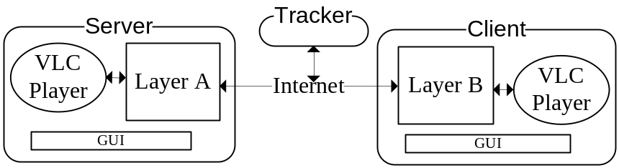
All work for media file encoding / decoding will be handle by the VLC player. Although I have pay certain time to study how to apply and compile the VLC player plug-in, however, we don’t need to study lots of media files format documents which will even take much more time.

System Library Development

Since lots of settings and users’ preference need to set/change within the system depends on various conditions. We design a GUI page for user to set/modify specific settings.

To store these setting and data, I develop a program to convert these data into XML file format. XML file can be view and edit easily which provide us great convenient for revise purpose.

We obtain the data that we are going to store from the GUI interface, then we using the program to convert these data into a XML file format, we just need to load that XML with the program while we need to attain those data again.

Client side Application Development

After the success of 1-to-many client-server model implementation, we start to pay our attention into develop our P2P system.

In our design, we have to set up a tree structure before to implement our push-based P2P algorithm. We have to set up a tree structure of peers’ connection for the system. So we further develop our client-side application, make it from a simple video receiver and player into upload video at the same time that it download. Make new clients can join to the old clients as role of sub-client, so form a tree structure.

While there’s new client join the system, it will register in the tracker server first. Then it will obtain a list of peers, applying the algorithm for establish the topology. If the new client has to join into the existing client in the system, it will send request to the peer just like it had done for main server. The existing client in the system will start to stream out video packets to the new client if it has available resources.

Since all packets received in the client side application are encoded, we can just redirect these packets to the sub-client while it received. As a result, the client side application will be upload at the same time it download, and contribute to the network. A simple tree structure network was then established.

Minutes of the 1st FYP Meeting
Date : 1/6/2009
Time : 10:30AM
Place : Room 2421
Attending : Prof. Danny Tsang,
Cheng Wen Chi, Chiu Kwok Shing, Choi Kwok Yam
Absent : None
Recorder : Chiu Kwok Shing

1. Items discussed
1.1. Recommended Schedule of the project
1.2. Recommended Protocol
1.3. Possible barriers
1.4. P2P protocol Reference

2. Problems/questions
2.1. What’s the first target of our project?
Conclusion: Develop an one-to-one client-server mode video streaming model.
2.2. Packet division / sending protocol and video encoding / decoding protocol
Conclusion: Investigate the possibility of applying VLC plug-in library.
2.3 How to apply VLC library?
Conclusion: Using C# as the developing language instead of C++, further investigate the implementation method by our own.
2.4 Does there any recommended papers for P2P IPTV?
Conclusion: Cool-streaming is recommended for reference.

3. Action items/tasks
Start working on Milestone 1 – Develop an one-to-one client-server mode video streaming model.

4. Date and time of next meeting
Next meeting will be held at the June-mid, further details of meeting date and time will be confirmed later by email.

5. Meeting adjournment
The meeting was adjourned at 11:30AM.

Minutes of the 2nd FYP Meeting
Date : 23/7/2009
Time : 3:30PM
Place : Room 2421
Attending : Prof. Danny Tsang,
Cheng Wen Chi, Chiu Kwok Shing, Choi Kwok Yam
Absent : None
Recorder : Chiu Kwok Shing

1. Items discussed
1.1. Report the current progress
Finish the target tasks that set in the 1st FY P meeting, 1-to-1 client-server mode video streaming model was set up.

1.2. Recommendation from Prof. Danny Tsang
Redevelop the system with VLC plug-in library instead of Windows Media Player plug-in.

1.3. Possibility of Implement MDC on our system

2. Action items/tasks
Implement the 1-to-many client-server mode video streaming model.

3. Date and time of next meeting
Next meeting will be held at the end of summer holiday, further details of meeting date and time will be confirmed later by email.

4. Meeting adjournment
The meeting was adjourned at 4:30PM.

Minutes of the 3rd FYP Meeting
Date : 8/9/2009
Time : 4:30PM
Place : Room 2421
Attending : Prof. Danny Tsang,
Cheng Wen Chi, Chiu Kwok Shing, Choi Kwok Yam
Absent : None
Recorder : Chiu Kwok Shing

1. Items discussed
1.1. Report the current progress
Finish the task set in 2nd FY P meeting, the system can stream out the video from server to multiple users.
1.2. Recommendation from Prof. Danny Tsang
1.3. How to make the streaming data into sub-streamming.

2. Action items/tasks
Implement sub-streaming to the 1-to-many client-server mode video streaming model.
Divide the server into Main server and Video Server.

3. Date and time of next meeting
Next meeting will be held at next month, further details of meeting date and time will be confirmed later by email.

4. Meeting adjournment
The meeting was adjourned at 5:30PM.

Minutes of the 4th FYP Meeting
Date : 15/109/2009
Time : 4:30PM
Place : Room 2421
Attending : Prof. Danny Tsang,
Cheng Wen Chi, Chiu Kwok Shing, Choi Kwok Yam
Absent : None
Recorder : Chiu Kwok Shing

1. Items discussed
1.1. Report the current progress
Finish the tasks that set in the 3rd FYP meeting.
1.2. Recommendation from Prof. Danny Tsang
1.3. Possibility that apply MDC on our system
Implementation on MDC will be further discussed by Prof. Danny Tsang and TA, recommendation and guidance would be given if they made a conclusion.

2. Action items/tasks
Develop a feasible P2P algorithm to our system, convert the system from client-server model to P2P model.

3. Date and time of next meeting
Next meeting will be held at next month, further details of meeting date and time will be confirmed later by email.

4. Meeting adjournment
The meeting was adjourned at 5:15PM.

Reference
[1] Laurie Gonzalez, Marketing Director of the Broadband Forum Asia, “IPTV DEPLOYMENTS DOUBLE FOR THE SECOND YEAR RUNNING AS BROADBAND CONTINUES TO ACHIEVE STRONG GROWTH”, 15 July 2008
http://www.broadband-forum.org/news/download/pressreleeases/2008/IPTV_Deployments_Double07_15_08.pdf
[2] Internet Protocol Television (iPTV) - Global Strategic Business Report, Global Industry Analysts, Inc., March 2008, Pages: 458 http://www.researchandmarkets.com/reportinfo.asp?report_id=347969&t=t&cat_id=
[3] Xiao jun Hei, Yong Liuz and Keith W. Ross:” IPTV over P2PStreaming Networks: the Mesh-pull Approach”, Communications Magazine, IEEE, Vol. 46, No. 2. (2008)
[4] ZhenjiangLi, YaoYu, XiaojunHei, and Danny Hin-Kwok Tsang: “A Uniﬁed Framework for Sub-stream Scheduling in P2PHybrid Streaming Systems and How to Do Better?”, P. 728-741, 7th May 2009
[5] F. Pianese, D. Perino, J. Keller, and E. W. Biersack, “PULSE: An adaptive, incentive-based, unstructured P2P live streaming system,” IEEE Trans. On Multimedia, vol. 9, no. 8, pp. 1645-1660, Dec. 2007
[6] Li, Z., Yu, Y., Hei, X., Tsang, D.H.K.: “Towards low-redundancy push-pull P2P live streaming”. In: Proc. ICST QShine, Hong Kong (July 2008)
[7] Xiao jun Hei, Chao Liang, Jian Liang, Yong Liu, Keith Ross: “A Measurement Study of a Large-Scale P2P IPTV System”. In Polytechnic University, NY, USA.
[8] Susu Xie, Bo Li, Gabriel Y. Keung, and Xinyan Zhang: “Coolstreaming: Design, Theory, and Practice “, IEEE TRANSACTIONS ON MULTIMEDIA, VOL. 9, NO. 8, DECEMBER 2007
[9] Alexandro SENTINELLI, Luca CELETTO, Damien LEFOL,Claudio PALAZZI, Giovanni PAU, Theodore ZAHARIADIS, Ahola JARI: “Survey on P2P Overlay Streaming Clients”, towards the Future Internet G. Tselentis et al. (Eds.) IOS Press, 2009
[10] Broadband Consumer Education Programme, Office of the Telecommunications Authority (OFTA) - HKSAR, 11 September 2008
http://www.ofta.gov.hk/en/ad-comm/ucac/paper/uc2008p6.pdf
[11] Source: Gartner, Science & Technology Policy Research and Information Center , July 2008
http://cdnet.stpi.org.tw/techroom/market/eetelecomm/2008/eetelecomm_08_033.htm
[12] Hong Kong: The Facts, Published by the Information Service Department – HKSAR OFTA, April 2009
http://www.gov.hk/en/about/abouthk/factsheets/docs/telecommunications.pdf

